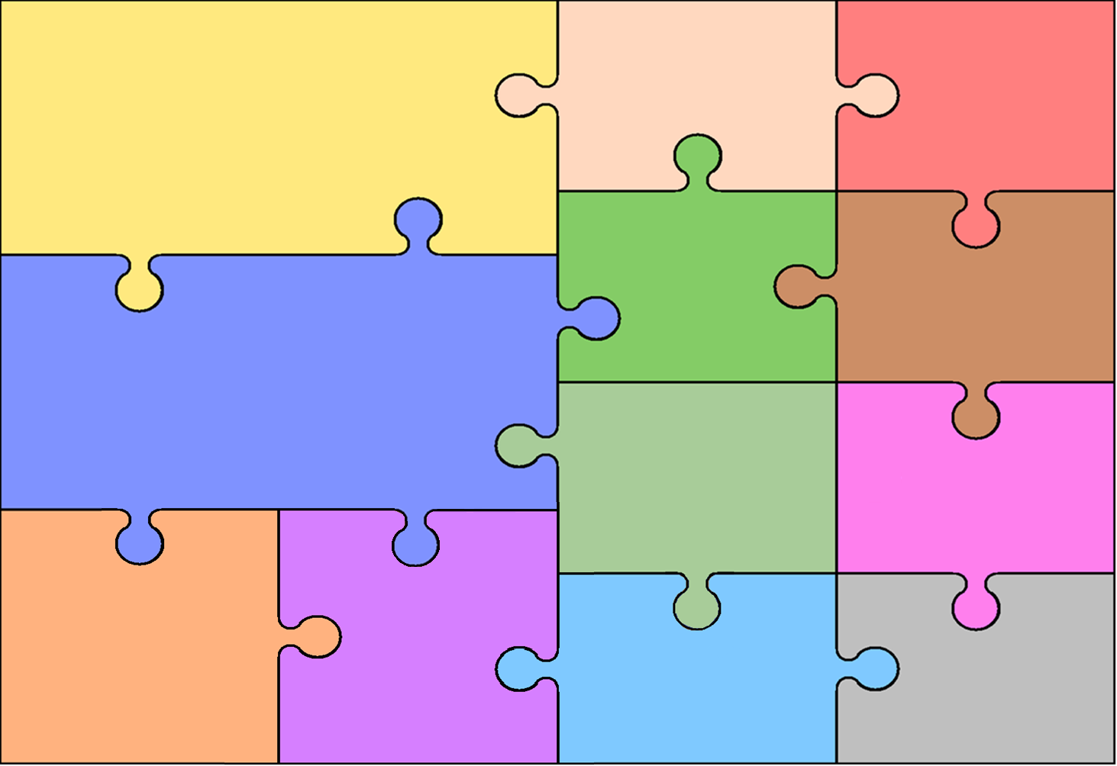
Curriculum Overview for Nursery – Spring 2026 To the Rescue!/ Into the Woods
Understanding the world.
Enjoy playing with small world, building on their first-hand experiences.
To be interested in different occupations.
To talk about some of the things they have observed such as plants, animals and natural objects.
To begin to understand the need to respect and care for the world.
Understand the life-cycle of a plant and animal.

Literacy
To react and respond to illustrations, characters and narratives through sharing books, using questions and imaginative play.
To maybe engage with print around them - digital and media texts.
To talk about stories
To add meaning to marks they make.
To make marks to be their name.
To identify the initial letter of their name.
To begin to make letter type shapes to represent the initial sound of their name.

Physical Development
To use large and small motor skills to do things independently - zips, buttons, pour drinks etc.
To want to be increasingly independent, e.g. dressing and undressing.
To self-select things that they want to use.
To use one-handed tools and equipment.
To experiment with mark making and emergent writing.
To begin to throw and release objects overarm.
To roll, crawl, jump and run with confidence.
To develop their shoulder, elbow and wrist pivot.
To participate in finger and action rhymes.

Personal, Social and Emotional Development
To seek out companionship with adults and other children.
To invite others to play and attempt to join in others’ play.
To have high levels of wellbeing and involvement.
Begins to show more confidence with unfamiliar people, in the safe context of their setting.
To begin to explore a range of emotions.
To begin to sort out minor conflicts and begin to accept that not everyone can be chosen.
To self-select activities and seek help if necessary.
Makes healthy choices about food, drink, activity.

Maths
To explore different shapes and sizes.
To recognise when two shapes are the same.
To compare sizes.
To compare amounts and use words like ‘lots’ and ‘more’.
To explore the difference in weight, length, size and capacity.
To begin to recognise numerals 0-10.
To solve everyday problems to 5

Communication and Language
To understand simple questions: who, what, where but generally not why.
Understand simple sentences
To listen to a simple story with the help of pictures.
To understand and act on longer sentences.
To respond to instructions with more elements, e.g., “Pick up the blocks and put them in the box.”
To use a wider range of words.
To try to use the correct tense although may muddle them up, e.g. “I bringed a bag.”

Expressive Arts and Design
To make simple models and talk about them.
To explore colours and colour mixing.
To take part in pretend play.
To enjoy taking part in action songs.
To move, sing and listen whilst playing instruments.

To create using small world and construction.

