Curriculum Overview for Year 6 - Spring 2026

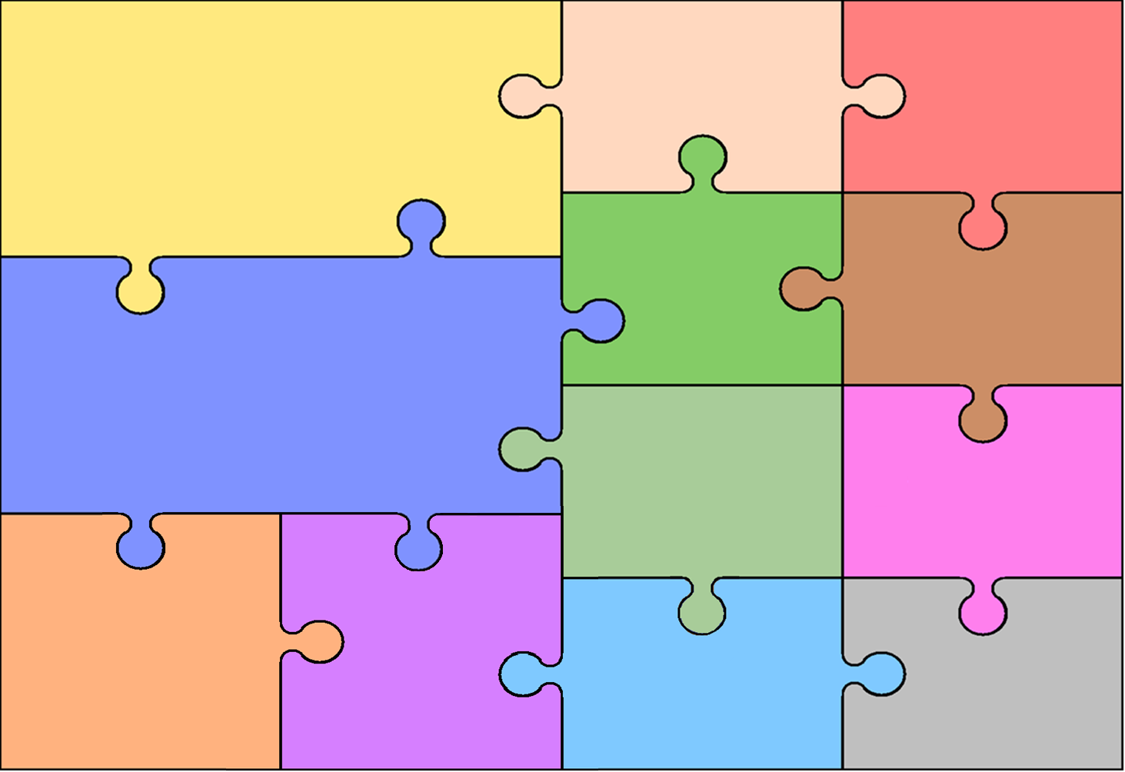
Topic
This term the children will engage in our new CUSP History topic. They will explore the Windrush Generation.

Children will also explore some aspects of Ancient Mayan civilisation through art.

History
- Learning about the impact and experiences of the Windrush Generation, and how they shaped modern Britain.
- Learning about the crucial role Caribbean men and women played in the Second World War.
- A case study on Sam King and his contributions to British society.

English
Writing
- Grammatical focus of semi-colon usage, colons and dashes and fronted adverbials.
- Literature focus on rhetorical questions to demonstrate state of mind.
- Using dashes, brackets and semi-colons to punctuate sentences.
- Using and punctuating dialogue correctly.
- Understanding and usage of passive voice.
- Using causal conjunctions to add cohesion to complex sentences.
We will be focusing on the following genres and text types this term:
- Fiction - Writing a discovery narrative in the context of Charles Darwin’s expedition.
- Fiction – Writing an explanation text and news report in the context of Charles Darwin.
- Non-fiction – Writing a documentary narrative based on The Ways of the Wolf.
- Non-fiction – Writing a balanced argument based on The Ways of the Wolf.

Design & Technology

Art

- Exploring traditional Mexican food and flavours.
- Designing our own Mexican-
inspired dish.
- Using a range of techniques to prepare ingredients.
- Cooking a dish with the application of heat.

- Exploring Mayan art including frescoes and sculpture.
- Developing accurate colour mixing.
- Designing a Mayan sculpture to be made using clay.
- Creating an armature (frame) using wire for clay to be applied to.
- Using decorative techniques to finish work.
Mathematics
- To know what settlements are and where they are found.
- To identify patterns in settlements, movement of people and economic activity.
- To know where the Lake District is and how it was formed.
- To explore the Tatra Mountains in Poland and Jamaica and the Caribbean.
•Use, read, write and convert between standard units of measures; length, mass, time, money and volume as well as imperial units
•Calculate the area of parallelograms and triangles
• Calculate, estimate and compare the volume of cuboids
•Compare and classify a range of geometric shapes
•Use angle facts to find unknown angles
•Draw a range of geometric shapes using given dimensions and angles
•Describe, draw, translate and reflect shapes on a coordinate plane
•Recognise and construct 3-D shapes
•Calculate the mean
•Construct and interpret lines graphs and pie charts
•Compare pie charts
•Use fractions to express proportion
•Identify ratio as a relationship between quantities and as a scale factor

Natural Selection
- Understanding the process of natural selection and how it shaped life on earth.
- How fossils provide evidence that living things have changed over time.
- Recognise that offspring inherit traits from their parents.
Biology
- Learning how nutrients and water are transported within animals.
- To understand the role of kidneys and how they keep us healthy.
Websites
- Evaluating existing websites and how they appeal to an audience.
- Designing a website whilst considering the key purpose.
- Using design software to produce a website delivering information about our topic.
Data and Spreadsheets
- Understand how to input data, sort it and filter it.
PE
Handball and football
- To play in a game abiding by the double dribble rule.
- The concept of screening and attempting it in a game.
- To show control of the ball when dribbling under pressure.
- To develop decision-making skills in game situations.

Geography
Computing
Dreams and Goals
- My dreams
- My goals
- How to achieve them
- Creating a dreams and goals timeline
Healthy Me
- Making positive eating choices
- Healthy lifestyle
- Exercise

Science
PSHE and
Citizenship

We will be learning about:
- Remembering Roots
- Being Courageous and Confident
- Being Regardful of Suffering
- Being Merciful and Forgiving (and being regardful of suffering)

RE

