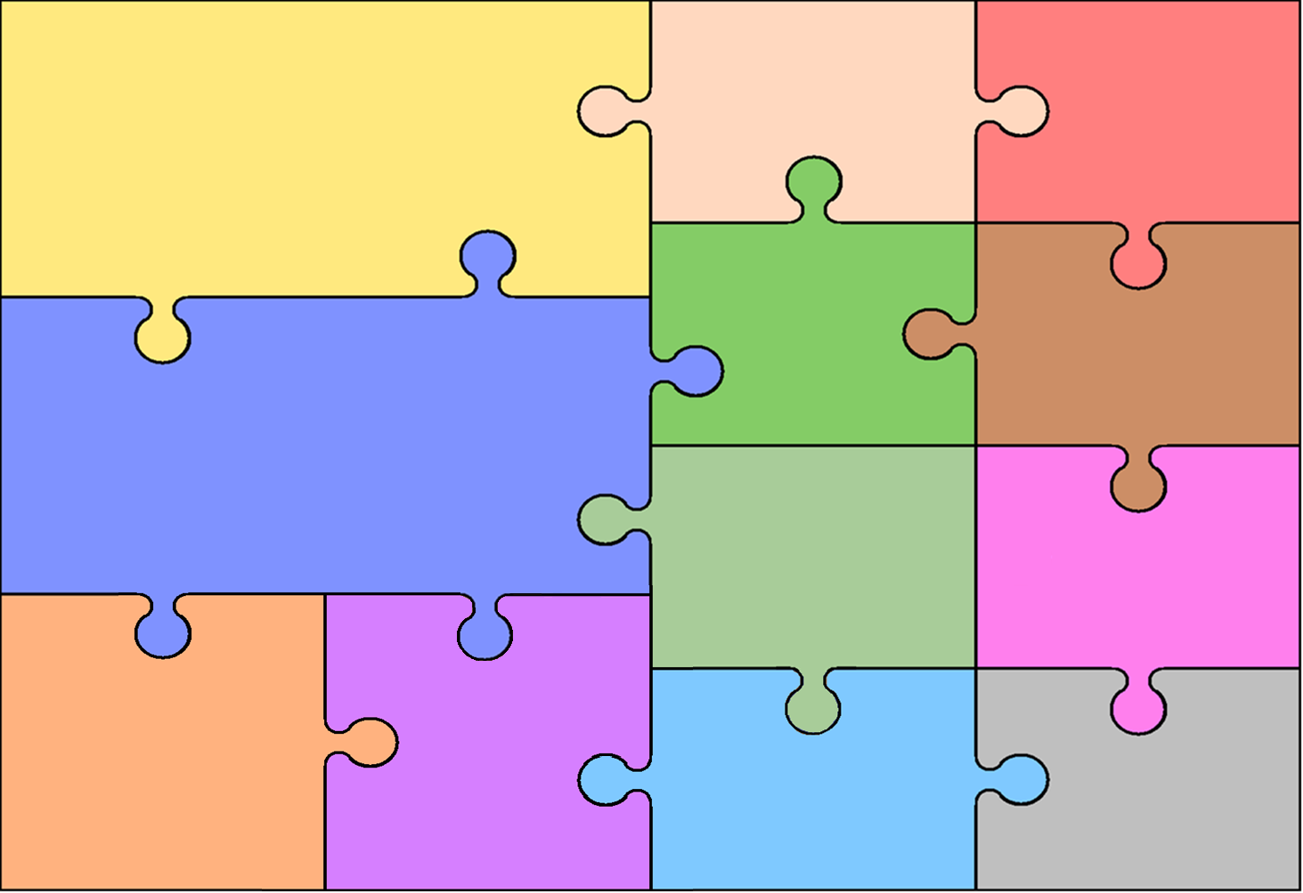
Computing
Video Production
Explore camera angles
Plan a storyboard of ideas for a video
Create a video
Evaluate their own video production.

Programming
Explore different types of quizzes.
Understanding selection to create quizzes
Control the outcome based on the answers given.

Curriculum Overview for Year 5 – Spring 2026
History

- Learn the chronology of Ancient Greece and understand how the Empire was established.
- Understand who were the Ancient Greeks and when did they rule.
- To learn about beliefs held by the Ancient Greeks.
- Identify City-states: what was the difference between Athens and Sparta.
- To learn about what happened at the Battle of Marathon? Why was it important?

English

Writing objectives:
- Know the difference between informal speech and formal tone.
- Use relative clauses using relative pronouns.
- Understand how commas clarify meaning.
- Use semi-colons for clauses.
- Link ideas across paragraphs, using adverbials
- Use hyphens to avoid ambiguity.
- Use semi colons, colons and bullet points
Reading objectives:
- Explain the meaning of words in context.
- Retrieve and record information from fiction and non-fiction texts.
- Summarise main ideas from more than one paragraph.
- Make inferences from a text.
- To predict what might happen from details stated and implied
- To identify and explain how information and narrative content is related and contributes
to meaning as a whole.
- To identify and explain how meaning is enhanced through choice of words and phrases
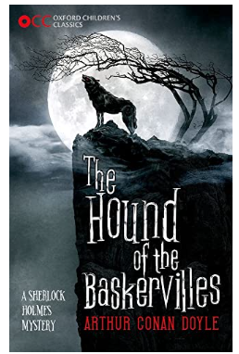
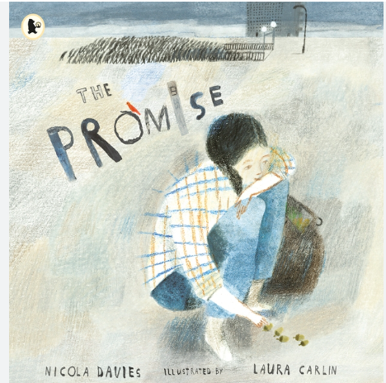

Art

Music

-To explore typical vases from the Ancient Greek period and identify key features.
-To experiment with techniques for working with clay.
-To design and make a Greek vase using clay.
-To use paint to decorate the final piece.
-To evaluate the effectiveness of their own design and techniques and identify how they would adapt this further.
Mathematics
-Create simple melodies using up to five different notes and simple rhythms that work musically with the style of the unit song.
-Explain the keynote or home note and the structure of the melody.
-Listen to and reflect upon the developing composition and make musical decisions about how the melody connects with the song.

- Hockey
- -To use fast, accurate passes into the D to create scoring opportunities.
- -To mark an attacker closely to stop them from receiving the ball.
- -To move the ball quickly from left to right to outwit a defender.
- Football
- - To travel quickly and effectively when running with the ball.
- - To combine running with the ball and sending it into space.
- - To maintain position when attacking to create space.

PE
-To use mapping skills effectively be able to find some of the major countries of the world.
-To recognise what a biome is and how they change the world (environmental region).
-To recognize the human features that define Europe, North and South America?
-To recognise physical features that define Europe, North and South America.
Earth and Space
- To learn the planets in our solar system?
- To understand why the rotation of Earth result in night and day?
- To understand how the Earth’s tilt (axis) is responsible for the seasons.

Living things and their habitats:
- To learn life cycle differences between a mammal and an amphibian?
- To compare what is similar and different between the life cycles of a mammal, an insect, an amphibian and a bird
- Plants and animals: To understand the life process of reproduction?

PSHE and
Citizenship

Dreams and goals:
- To identify jobs I would like to do and the motivation needed to achieve this.
- To aspire to meet my goals.

Healthy me
- To know the risks associated with cigarettes and alcohol.
- To know how to follow a healthy lifestyle through exercise and diet.

Design and Technology

-To explore gears and pulleys as mechanisms.
-To evaluate existing designs.
-To design a model which could be powered by a mechanism, taking design criteria into account.
-To use a plan to make a model.
-To evaluate their own design.

Fractions and decimals
- Read, write, order and compare decimals.
- Round decimals to the nearest whole number
- Represent, identify, name, write, order and compare fractions (including improper and mixed numbers)
- Calculate fractions of amounts.
Angles
- Classify, compare and order angles
- Measure a draw angles with a protractor
- Understand and use angle facts to calculate missing angles
Fractions and percentages
- Add, subtract fractions with denominators that are multiples of the same number
- Multiply fractions (and mixed numbers) by a whole number
- Explore percentage, decimal, fractions equivalence
Transformations
- Coordinates in all four quadrants
- Translation and reflection
- Calculate intervals across zero as a context for negative numbers

-To understand how to be hopeful and a visionary.
-To understand sharing and being generous.
-Being Attentive to the sacred as well as the precious
-Being Loyal and Steadfast
-Participating and Willing to Lead
-Being Modest and Listening to Others

Geography
RE
Science

