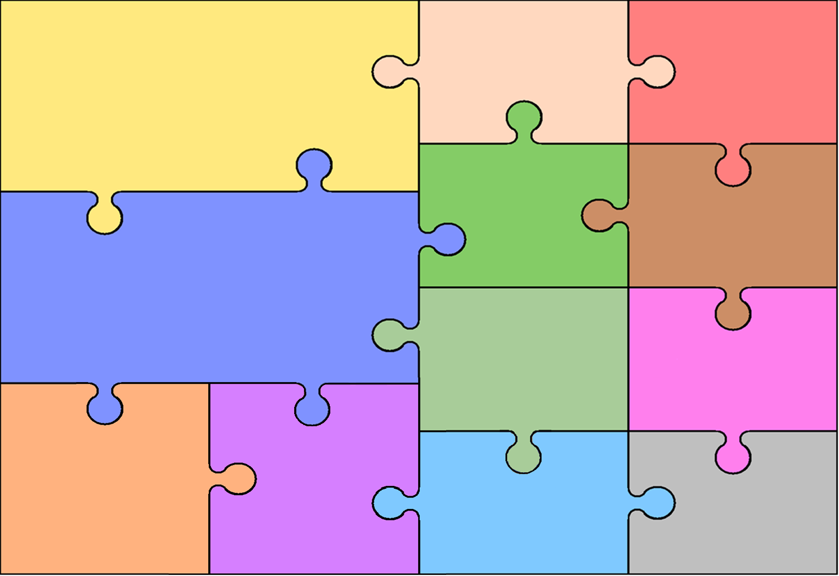
Curriculum Overview for Year 4 – Spring 2026
History
- To understand who the Anglo-Saxons came to Britain and where they came from.
- To explore chronology and understand the terms BCE and CE.
- To understand what life was like for an Anglo-Saxon
- To learn about the Viking invasion of Britain.
- To understand the agreement made between Anglo-Saxons and Vikings.
From Longboats to Kingdoms
This term the children will engage in our new CUSP History topic. They will explore settlement of Anglo-Saxons and Vikings in Britain.

English

Children will be introduced to the high-quality texts ‘Arthur and the Golden Rope’ and ‘The lost Happy Endings’.

We will be writing a myth narrative, an information guide, a twisted narrative and a persuasive letter and will focus on the following skills:
- Forming paragraphs around a theme.
- Using a variety of sentence types effectively
- Using inverted commas and other punctuation accurately in speech.
- Use possessive apostrophes accurately in regular plurals and in words with irregular plurals.
- Focus on verb inflections and nouns/ pronouns to avoid repetition and aid cohesion.
- Developing understanding of spelling rules.

Reading:
- Inferring information from fiction and non-fiction texts

and justifying the answers.
- Summarising their understanding of what they have read.

Writing:

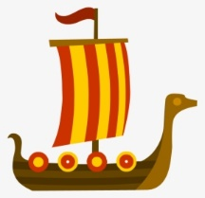

Art

Music

- To explore Anglo-Saxon designs and evaluate them.
- To plan and design my own piece using by incorporating aspects of designs from the past.
-To construct an Anglo-Saxon style cross and brooch using a range of materials.
- To use a range of finishing techniques when decorating my artwork.
- To evaluate the effectiveness of my work and how I would develop it further.

This term, children will continue to develop their skills playing the tenor horn.
They will play a wide range of songs and focus on timing and playing notes accurately.
Mathematics

Multiplication & Division
- Multiply three-digit numbers by a one-digit number using formal written layout
- Solve problems involving multiplying and dividing
- Use place value, known and derived facts to multiply and divide mentally
Fractions
- Recognise and show, using diagrams, families of common equivalent
- Solve problems involving increasingly harder fractions to calculate quantities, and fractions to divide quantities,
- Add and subtract fractions with the same denominator
Decimals
- Compare numbers with the same number of decimal places up to 2 decimal places
- Solve simple measure and money problems involving fractions and decimals to 2 decimal places
- Recognise and write decimal equivalents to 1⁄4, 1⁄2, 3⁄4
Time
- Read 12 hour analogue and digital 12 hour clocks. Read and understand 24 hour time.
- Convert hours, minutes and seconds. Convert years and months and weeks and days.
- Solving problems using knowledge and understanding of time.

Geography
RE
Hockey
- To perform a push pass with accuracy.
- To dribble the ball and maintain possession.
- To turn to keep the ball under control and move into a new space.
- To apply skills to competitive games.

Gymnastics
- To explore a sequence of movements involving balance, concentrating on floor work
- To develop climbing and balancing - To use balance through equipment at different heights
- To combine movements and balance through travelling movements across apparatus
PE
- To understand what a line of latitude is.
- To understand what a line of longitude is.
- To know that latitude and longitude tell us what a location will be like.
- To know how to find exact locations around the world.
- To know what time zones are and how they affect us.
Animals Including Humans

- To identify the different types of teeth and their function.
- To know how the mouth and teeth aid digestion.
- To explore whether teeth tell us what an animal eats.

Electricity

-To know which appliance use electricity and what sort of power makes them work.
- To name the components in a simple series circuit.
- To investigate what the effect on a circuit then components or batteries are changed.

Science
Design and Technology
- To investigate sewing techniques.
- To design an Anglo-Saxon style purse for holding money.
- To use stitching techniques to join materials together.
- To use simple embroidery to add a final design
- To evaluate the effectiveness of their product.
Dreams and Goals
- To tell you about some of my hopes and dreams
- To know how to make a new plan and set new goals even if I have been disappointed
- To know how to work out the steps to take to achieve a goal.

Healthy Me
To recognise how different friendship groups are formed, how I fit into them and the friends I value the most
- To understand the facts about smoking and its effects on health, and also some of the reasons some people start to smoke
- To understand the facts about alcohol and its effects on health, particularly the liver, and also some of the reasons some people drink alcohol
Being Modest and Listening to Others
- To understand that the significance of Jesus’ teaching is shown in the actions of his followers.
- To explore the Sikh Amrit ceremony.
- To explore the significance of Hajj, as a religious practice, for Muslims

Being Merciful and Creating Inclusion, Identity and Belonging
- To understand how religions and communities show belonging. - To begin to understand that religious scriptures teaches inclusion and belonging.

PSHE and
Citizenship

