Curriculum Overview for Year 3 – Spring Topic : Stone Age to Iron Age

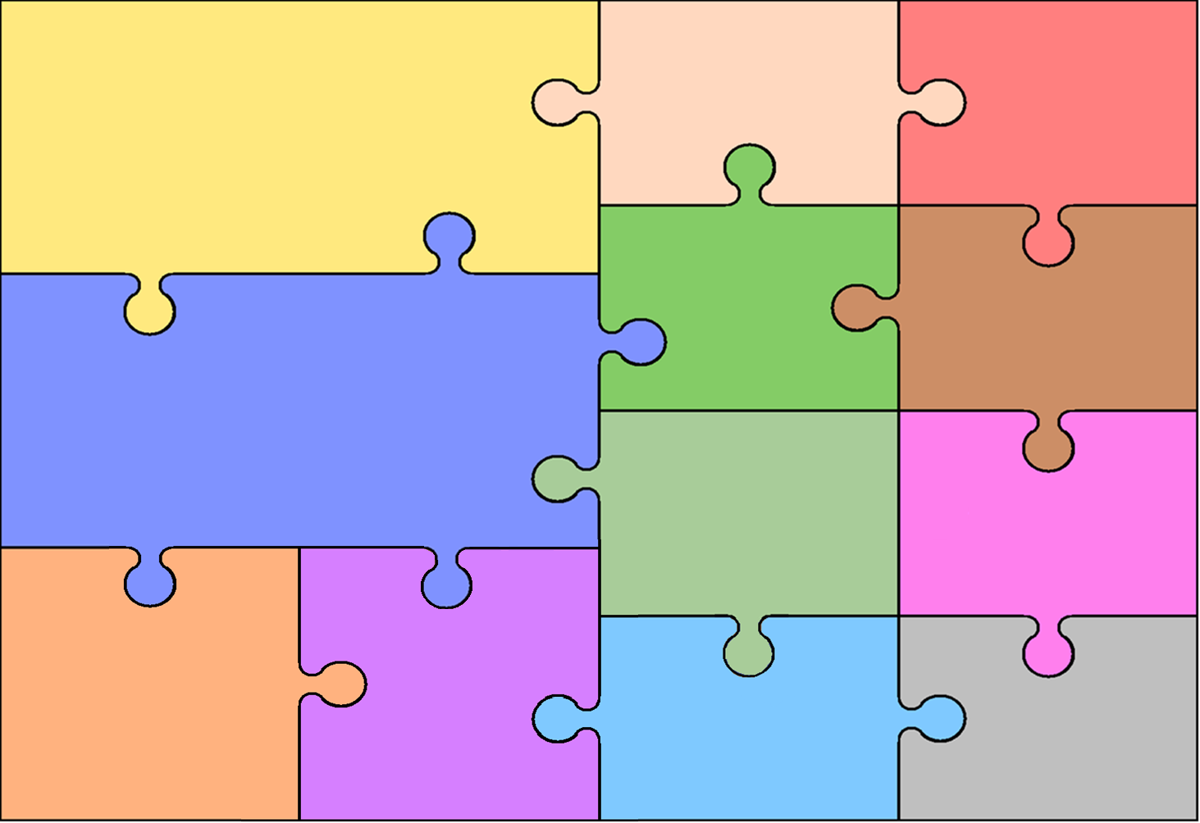
Topic
History – Stone Age to Iron Age
The changes in Britain from the Stone Age to the Iron Age.

Geography - Study Countries and Regions of the United Kingdom
The physical and geographical features of town and cities of the UK.

English
Writing
Write a setting narrative.
Write an information leaflet.
Write a narrative.
Write a newspaper report.
Spelling lists following the Year 3 National Curriculum expectations.
Reading
Reading a range of fiction and non- fiction texts.
Explain and justify inferences from texts read.
Understanding new words in different contexts.

PSHE
Dreams and Goals
Ambitions for the future

Healthy Me
Being Healthy and Safe

RE
Disposition:
Participate and Willing to Lead

Disposition:

Being Fair and Just

Mathematics

Fractions
Time
Multiplication and Division
Calculating with Multiplication and Division
Exploring calculation strategies and place value

Science
Forces and Magnets
Plants
MFL - Spanish
Inside the Classroom – La clase
My Family – Mi familia

Computing
Moving Pictures
Creating Sprites in Scratch

Music
Whole class music lessons
Three Little Birds
Dragon Song

Design & Technology
To investigate the types of food eaten in the Strone Age.
To evaluate soups and make a healthy soup.
Art
To evaluate Cave Art and how it supports our understanding of Stone Age life.
To create a piece of cave art using taught skills.

Art

PE

Handball
Basketball

