Curriculum Overview for Year 2 – Spring 2026
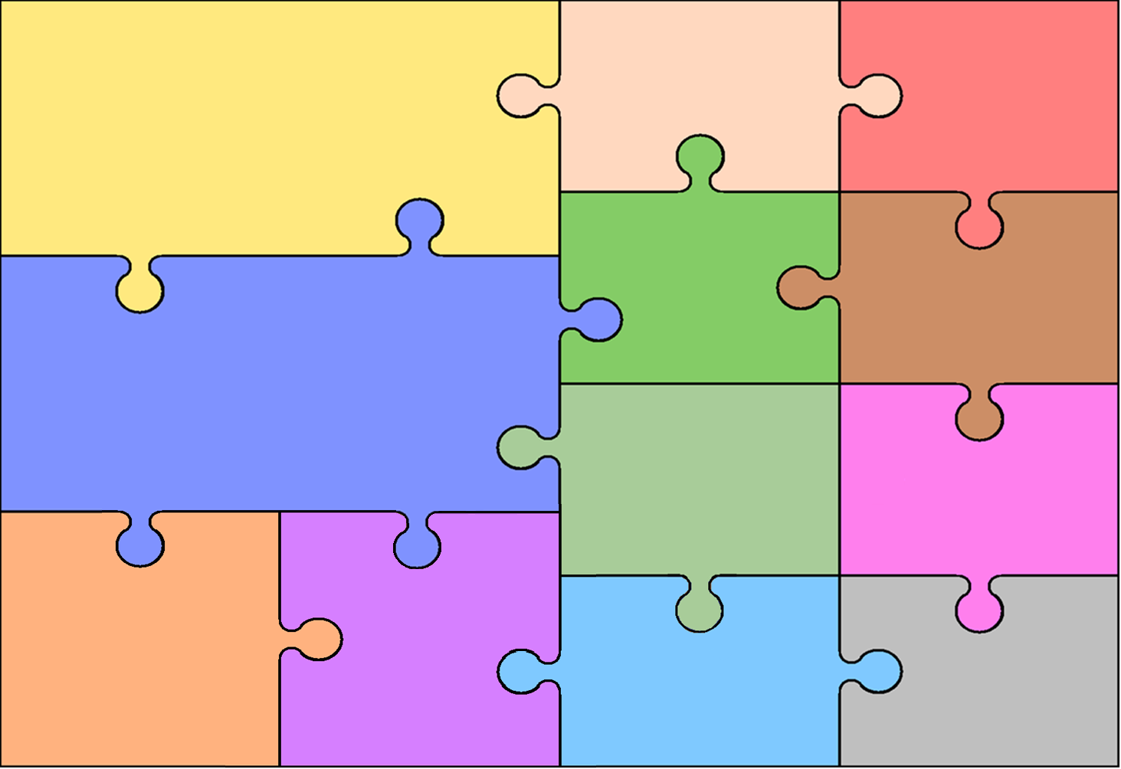
History
Great Fire of London

Pupils are taught about events beyond living memory that are significant nationally or globally.
This study looks at the cause and effect of the Great Fire of London
This event happened a long time ago – over 350 years. The chronology focuses on the events over a few terrible days rather than a depth study into the period of time

English

Fiction: Finding tale Non-Fiction: Instructions
Writing
- Investigating spelling patterns and generate their own spelling rules
- Using sentences with different forms in their writing – exclamations, questions, statements and commands
- using present and past tense mostly correctly and consistently
- using co-ordination (or / and / but) and sub ordination (when / if / that / because)
- Use a range of KS1 punctuation , . ? !
Reading
- Phonics – using phonics to read new words and spell them
- Comprehension – answering questions about what we have read in detail
- Reading common exception words fluently

Geography

- Use world maps, atlases and globes
- Use simple compass directions and locational and directional language for example, near and far; left and right
- Use aerial photographs and plan perspectives to recognise landmarks and basic human and physical features; devise a simple map; and use and construct basic symbols in a key
- Use simple fieldwork and observational skills to study the geography of their school and its grounds

Science

Uses of every day materials
- identify and compare the suitability of a variety of everyday materials, including wood, metal, plastic, glass, brick, rock, paper and cardboard for particular uses
- find out how the shapes of solid objects made from some materials can be changed by squashing, bending, twisting and stretching

RE

Spring 1 Creating unity and harmony – The children will be learning all about how all religions value unity and equality and how they teach this to their followers.

Spring 2 - Caring for Others, Animals, and the Environment – The children will be learning all about how all the religions respect and care for people, animals and the world we live in.

PE

Computing

Sp 1 - Algorithms + Programming
Control onscreen devices (3D modelling)
Predict the behaviour of simple programs (3D modelling)
Sp2 – Pictograms
Entering data
Creating pictograms

Music
Learning to play and sing songs called:

I Wanna Play in a Band
Zoo Time

Mathematics

- Addition:
- Subtraction
- Multiplication: repeated addition and grouping approaches
- Division: Sharing approaches
- 2 times tables
- 5 times tables
- 10 times tables
- 3 times tables
- Measurement
- Money

Design & Technology

- Children will explore materials that are used to make kites
- Children will explore different kite shapes
- Children will make a kite

Spr 1
Hit, Catch and Run
Spr 2
Send and return

