Food and Nutrition policy
Barford Primary School



2025/26

Overall aim of the Policy
The Department of Education’s updated Early Years Foundation Stage Nutrition guidance supports providers in meeting the Early Years Foundation Stage (EYFS) statutory framework requirement ‘Where children are provided with meals, snacks and drinks, these must be healthy, balanced and nutritious’.
From September 2025, the EYFS statutory framework will include a safeguarding and welfare requirement that asks providers to follow this nutrition guidance unless there is good reason not to.
The aim of this policy is to
- promote the health and wellbeing of the children and their families through food within Barford’s Early Years setting.
- to establish good food habits and help reduce obesity
- to help children and parents gain the knowledge of how to keep themselves healthy.

Development and Implementation of the Food policy:
- to ensure that all staff, parents, carers and children are aware of the setting's approach to food and drink provision and learning about food
- to ensure that parents and carers are provided with the knowledge and information they require about the food and drink provision at the setting
- to ensure children receive consistent messages about healthy eating When and to whom the Policy applies:
- to food provided by the setting, to food brought in from home, food provided at events or on trips
- to all staff within the setting, including those planning menus, (food menus are created by Shire catering as part of the school meals contract in school) cooking, preparing and serving food and to parents who bring food into the setting from home
- to ensure that everyone who it applies to is aware of our food policy we will send copies to parents and invite them into the setting to discuss it. There will be healthy eating workshops provided for EYFS children and throughout the PSHE and science teaching program for the rest of the school.

Food and Drink Provision
- Fresh water is freely available at all times.
- Snack time is provided by the setting and home during the morning session and the afternoon session. Food and drink provided by the setting follows the Healthy eating guidelines, taking into account the dietary needs of the cohort of children. This includes a variety of seasonal fruit and vegetables. Other healthy snacks are provided by home and these follow the nutritional guidelines in the April 2025 DfE Nutrition document. Water is provided as a drink at snack times and lunch times and throughout the day.
- Lunch is provided by either parents with lunch boxes or through school hot lunches provided by Shire catering. Children's lunchboxes are monitored as the staff help the children to eat their lunch and on occasions parents may be advised on ways to include more healthy food in their child's packed lunch.
- No chocolate / sweets in lunchboxes or as a snack are permitted.

Communicating with children and Families
Snack times and lunch times are an ideal opportunity when everyone is gathered around the table to discuss healthy eating and why it is important. Healthy eating is also talked about through play, with role-play and play foods being an obvious vehicle for good discussion and learning. Cooking is a regular activity within the settings and provides an ideal environment to discuss food and healthy eating. Parents are encouraged to contribute to and attend special events and celebrations, workshops and stay and play sessions that incorporates food and cooking. The school nurse runs workshops with the children and parents at Barford and this includes information and guidance on healthy eating. The eating environment and social aspects of mealtimes
All children and staff wash their hands before eating meals and snacks. Children are required to sit at the table to eat as this provides a sociable environment where they can talk to their friends, and a safe place to eat. In warmer weather, snack times may take place outdoors in the covered seating area or on picnic benches. They are always accompanied by an adult. Children are always given a choice of the foods provided and encouraged to try new foods. We involve the children as much as possible in the setting up and clearing away of snack time. At lunchtimes the staff always supervise children whilst they eat. Children eat at different rates so therefore they are given as much time as they need to eat in comfort.
Children are not to share food with others and school appreciates home support in teaching this message.

Providing food for all-allergies and dietary requirements
It is important that settings provide food for children following special, cultural or religious diets, including children with food allergies, and manage this appropriately and effectively. We talk to the family when the child starts our school to find out about all their needs including dietary. We ensure that all staff are made aware of these needs by details on the Registration forms and on the Snack list, with all allergies written in bold. Either the setting, or parents if they wish, provide alternatives. No child is ever made to feel different from the others because of their dietary needs.
Any food allergies are noted and all staff including lunch staff are aware of any dietary needs or allergies.

Encouraging fussy eaters to eat well
Fussy eating and fear of new foods are part of early childhood development and can affect between 10% and 20% of children under 5. A child who appears fussy about their food but is growing well is probably eating a sufficient balance of foods and getting enough energy and nutrition. Severe selective eating is rare and generally starts from early feeding difficulties or significant health problems. In cases like these we would be guided by other health professionals. For the majority of children who are fussy eaters, we ensure that they are seated with non-fussy eaters who provide good peer models and we encourage positive discussion about the foods eaten. Children are never forced to eat something new but are always encouraged to try a small bit. Praise is always given for trying new foods.

Food brought in from home
Lunch and snack can be provided by the parents at Barford. We advise parents in any way we can and this does include suggestions for healthier lunchboxes within our regular feedback to parents and courses. We respect parents' economic circumstances and aim to support parents to make healthier lunchboxes. However, we do stipulate no chocolate or sweets in lunchboxes or for snacks. We have a regulatory responsibility to provide healthy, balanced and nutritious food and so we as a school encourage healthier food options.

The ’Lunchbox Builder’ chart gives some guidance as to how to create a healthy, balanced lunch using wholefoods and non ultra-processed foods vital for healthy development, weight and energy levels.
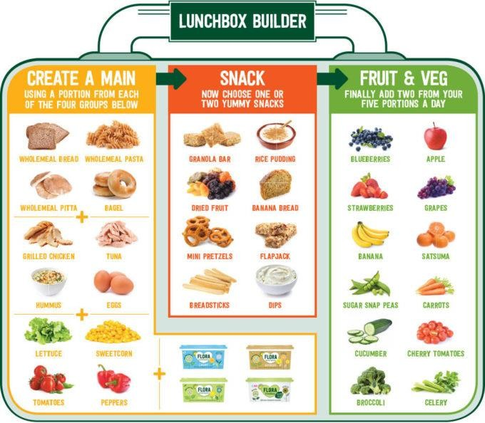
Best practices for packing lunch boxes:
- Ensure the food is suitable for their child’s individual developmental needs and prepared in a way to prevent choking – foods should be in small pieces which do not constitute a choking-hazard, eg grapes, cherry tomatoes etc should be halved and the halved again into quarters.
- For perishable items that should be kept cool, pack food in insulated sealed bags. If ice packs are unavailable, the ‘4-hour rule’ can be applied. This rule allows food to be stored outside of chilled conditions for up to 4 hours, but this should only be done once during the entire storage.
- Clearly label your child’s name on the lunch bag and detail the contents.
- Pack foods that can safely be kept at room temperature, as there is no refrigerated area for storing food brought from home.

The Food Standards Agency provides advice on Listeria which has examples of ready-to eat foods that should be eaten within 4 hours of removing them from the fridge. Providers do not have to provide refrigeration for packed lunches of children. Likewise, providers are not required to reheat food brought in by children.

Learning about and through Food
Learning about and through food is relevant through all 7 areas of the Early Years Foundation stage curriculum.
- Personal, social and emotional development – Mealtimes and cooking activities offer children experiences to taste different foods, overcome dislikes and learn how to share. Cooking activities offer opportunities for learning through working with others and increasing self-esteem
- Physical development – Fine and gross motor skills can be developed through activities such as gardening, using knives and forks, preparing food and washing up. Mealtimes can be used to help children make healthy choices.
- Literacy – Many stories involve food. They can be used to teach about ingredients, where food comes from and about food for special occasions and from different cultures. Language can be developed and senses explored through discussing and describing the taste , texture, size, look and smell of food.
- Mathematics – Activities such as weighing ingredients or counting pieces of fruit when enjoying snack time can be used to support numeracy skills. Sorting and matching foods into different types can help promote organisational skills and reasoning.
- Communication and Language -sitting around the table eating food together is a good way to teach conversation and social skills such as looking after neighbours.
- Understanding the World – food tasting activities teach children about ingredients, the seasons, and where food comes from, including food from different cultures. Growing fruit and vegetables teaches children about where food comes from, about life cycles, about gardening and how to look after plants. It is also a good form of physical activity.
- Expressive Arts and design – Art activities can engage children with food and alert them to colours and shapes.

Cooking with children
Cooking with children is both an enjoyable activity in its own right and an effective way of encouraging all children to try and eat a wide range of foods. We ensure that all children have the opportunity to cook regularly and involve them in measuring, mixing, cutting and chopping (including safe handling of tools) and stirring to make a variety of recipes. We work in small groups with adult supervision at all times. We discuss the changes that have occurred when foods have been heated. Food Safety and Hygiene
All those who are involved in preparing and handling food are trained to do so. Lunches are delivered to school by City Serve catering. Food is prepared in the school kitchen of Barford Primary school. We make sure that the children understand why it is important to always wash their hands before they take part in cooking activities or eating and why it is not safe to eat food that has been dropped on the floor.

Sustainability
We endeavour to be as sustainable as possible, limiting our food waste and recycling any food waste in school as much as possible. We have school compost bins as well as a wormery that make good use of any food waste. We also try to grow some foods to supplement the foods provided in our very own allotment.

Protecting children's health
Everyone working at Barofrd has a responsibility to protect children’s health: this includes helping children to maintain a healthy weight as they grow. We also encourage good dental practices -children take part in dental health workshops with the school nurse - and the school nurse completes height and weight checks in both Reception and Year 6. If we have concerns, we will talk to the child's parents and /or other health professionals.

Celebrations and Special Occasions
Our school has children from a range of cultural backgrounds. If they have different dietary needs this is discussed with the parents when the children start to ensure that we can cater for them whenever possible. Even if there are no children from minority ethnic, cultural or religious groups attending, it is still important to introduce all children to a variety of foods and so they can learn to appreciate the diets of different cultures. We work closely with the families from ethnic minorities so that we can share in and learn about their festivals and celebrations.
Many families like to celebrate their child’s birthday and other special events by bringing in a cake or sweets to school to share. This is a lovely celebratory gesture, but can mean that some children are eating these unhealthy foods several times a week. We recommend as a school that where possible, any celebratory treats or snacks are balanced and nutritious such as a fruit platter or possible non-edible such as bubbles or stickers. Any food shared in the setting should be checked for potential allergens.
In addition to this, please ensure any foods are clearly labelled with ingredients in line with Natasha’s Law.

