
Year 4 – Art and Design Autumn 1, Spring 1, Summer 1
Design and Technology Autumn 2, Spring 2, Summer 2
Curriculum Overview Template – Birmingham 2026/27

Half-term: 26–30 October 2026
 | Autumn 1 – Art and Design |  |  |  |  |  |  |  | Autumn 2 – Design and Technology
AUTUMN | Week 1 | Week 2 | Week 3 | Week 4 | Week 5 | Week 6 | Week 7 | HALF  TERM  BREAK | Week 8 | Week 9 | Week 10 | Week 11 | Week 12 | Week 13 | Week 14
AUTUMN | Drawing Block A |  |  |  | Painting Block B |  |  | HALF  TERM  BREAK | Food and Nutrition Block A |  |  | Mechanisms Block B |  |  | Flexible Content
AUTUMN | 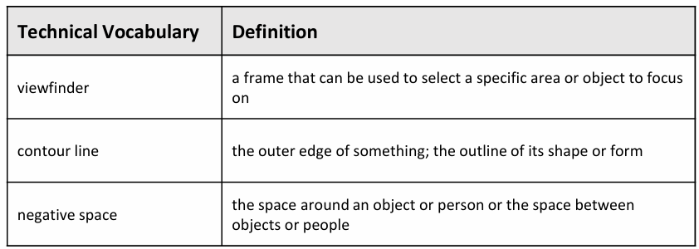  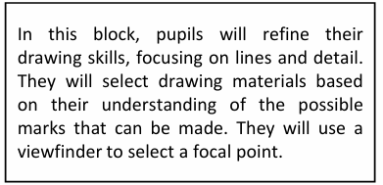 |  |  |  | 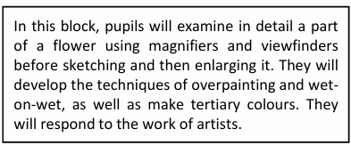  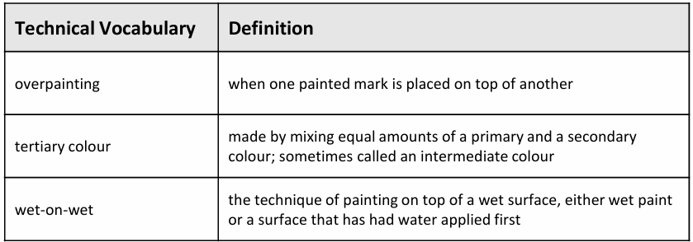 |  |  | HALF  TERM  BREAK | 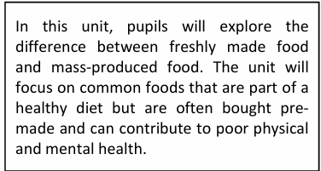  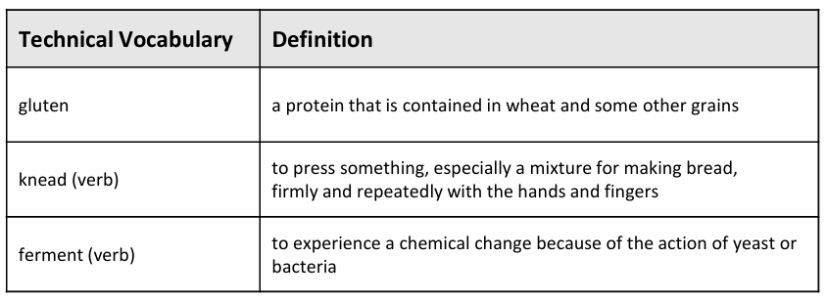  What’s really in your food? |  |  | 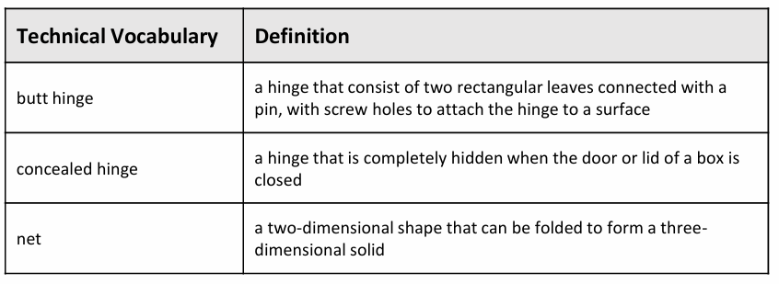  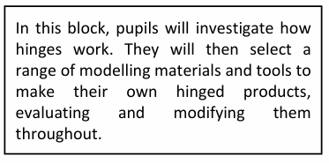  How many ways are there to open a door? |  |  | Flexible Content

Half-term: 15–19 February 2027
 | Spring 1 – Art and Design |  |  |  |  |  |  | Spring 2 – Design and Technology
SPRING | Week 1 | Week 2 | Week 3 | Week 4 | Week 5 | Week 6 | HALF  TERM  BREAK | Week 7 | Week 8 |  | Week 9 | Week 10 | Week 11
SPRING | Printmaking and Textiles Block C |  |  | 3D Block D |  |  | HALF  TERM  BREAK | Textiles Block C |  | Structures Block D
SPRING | 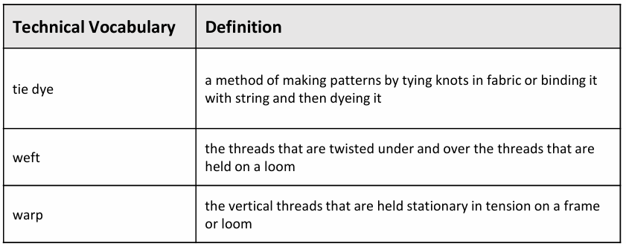  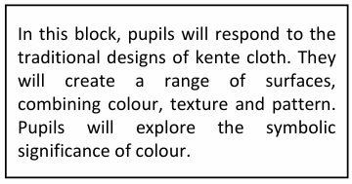 |  |  | 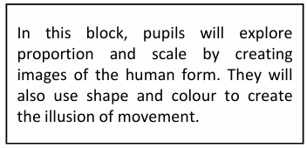  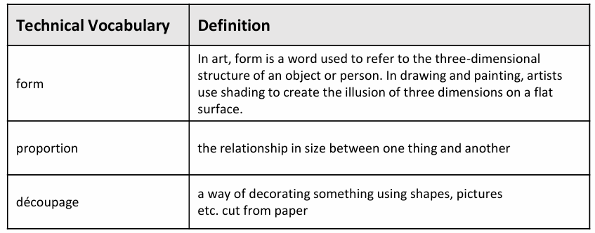 |  |  | HALF  TERM  BREAK | -  How do you keep a tea towel from slipping off a hook? 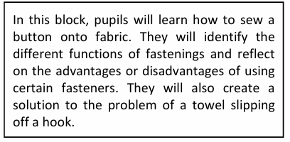  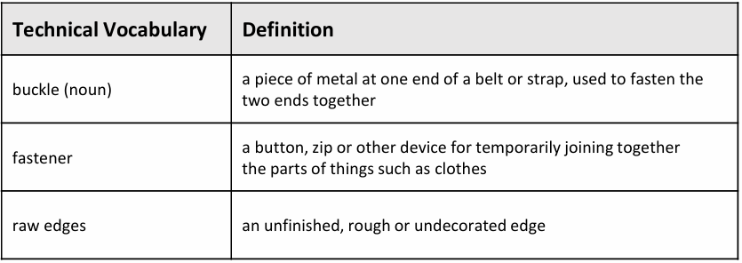 |  | 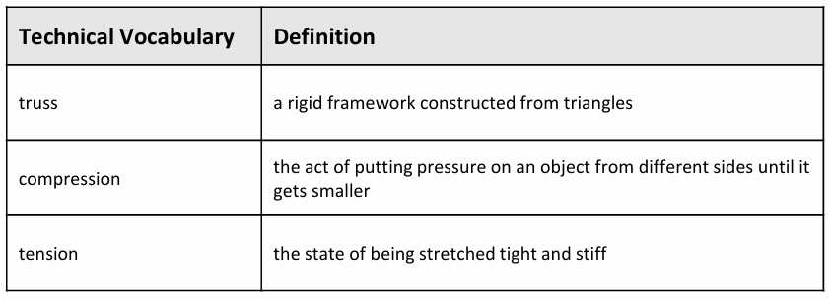  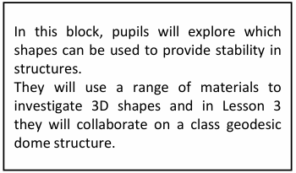  Which shapes will give you a structure stability?

Half-term: 31 May–4 June 2027
 | Summer 1 – Art and Design |  |  |  |  |  |  |  | Summer 2 – Design and Technology
SUMMER | Week 1 | Week 2 | Week 3 | Week 4 | Week 5 | Week 6 | Week 7 | HALF  TERM  BREAK | Week 8 | Week 9 | Week 10 | Week 11 | Week 12 | Week 13
SUMMER | Painting Block E |  |  | Creative Response Block F |  |  | Flexible Content | HALF  TERM  BREAK | Electrical Systems Block E (Science link) |  |  | Structures Block F
SUMMER | 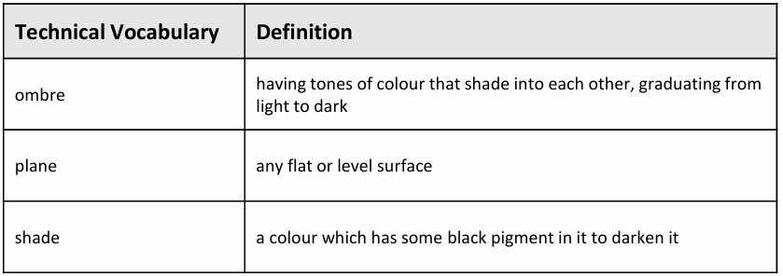  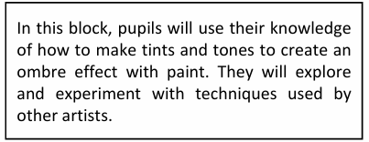 |  |  |  |  |  | Flexible Content | HALF  TERM  BREAK | How useful are switches?  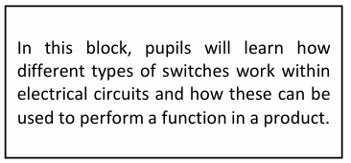  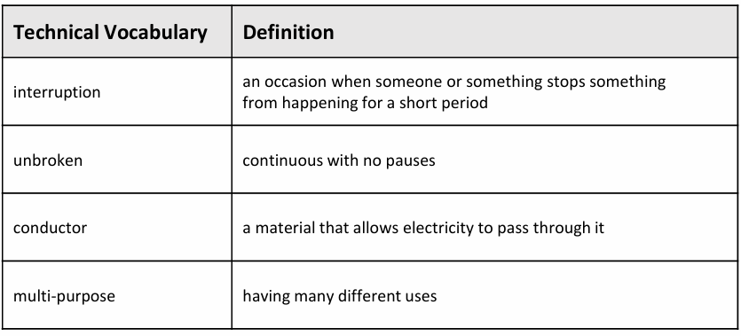 |  |  | 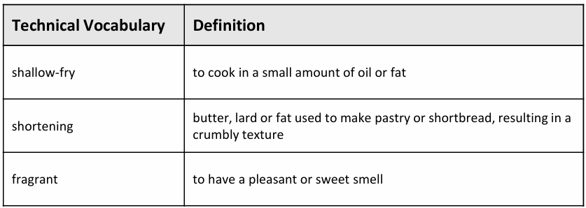  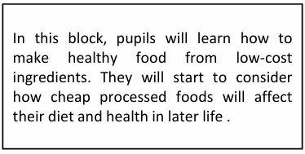  Is cheap food always worse for you?

