
Year 1 – Art and Design
Curriculum Overview Template – Birmingham 2026/27

Half-term: 26–30 October 2026
AUTUMN | Week 1 | Week 2 | Week 3 | Week 4 | Week 5 | Week 6 | Week 7 | HALF  TERM  BREAK | Week 8 | Week 9 | Week 10 |  | Week 11 | Week 12 | Week 13 | Week 14
AUTUMN | Drawing Block A |  |  |  | Painting Block B |  |  | HALF  TERM  BREAK | Mechanisms Block A |  |  |  | Structures Block B |  |  | Flexible Content Food and Nutrition lesson 1
AUTUMN | 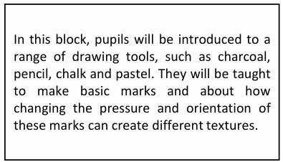  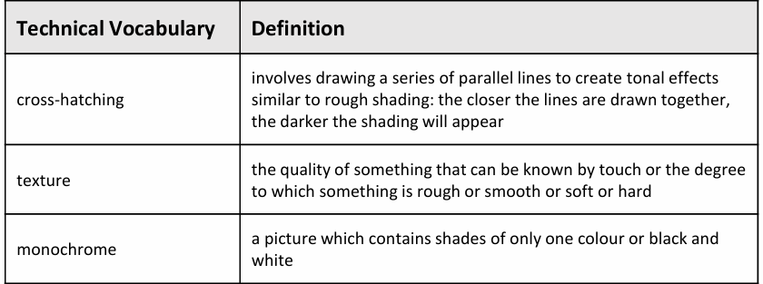  Core knowledge: drawing, pressure and orientation |  |  |  | 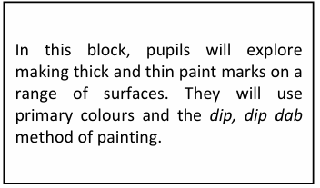  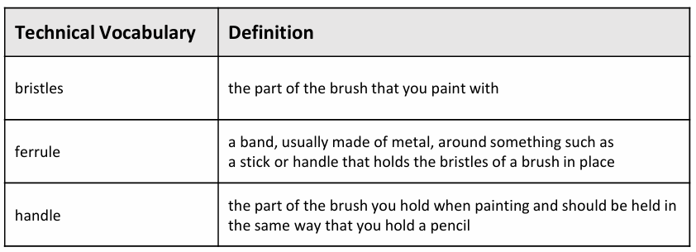  Core knowledge: palette, primary colours and brushstroke |  |  | HALF  TERM  BREAK | 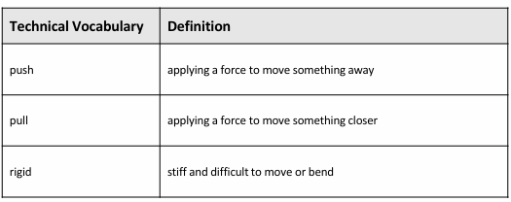  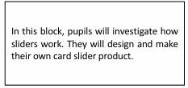 |  |  | 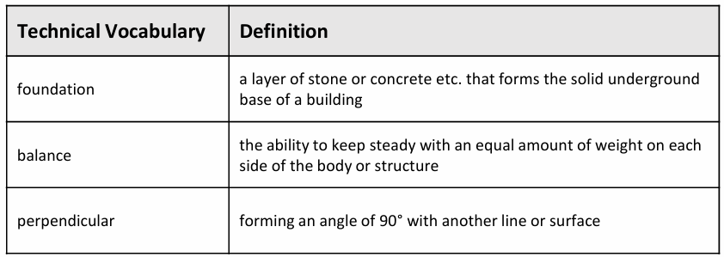  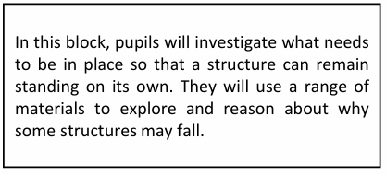 |  |  |  | Flexible Content Food and Nutrition lesson 1

Half-term: 15–19 February 2027
SPRING | Week 1 | Week 2 | Week 3 | Week 4 | Week 5 | Week 6 | HALF  TERM  BREAK | Week 7 | Week 8 |  | Week 9 | Week 10 | Week 11
SPRING | Printmaking Block C |  |  | Textiles Block D |  |  | HALF  TERM  BREAK | Food and Nutrition Block C |  | Materials Block D
SPRING | 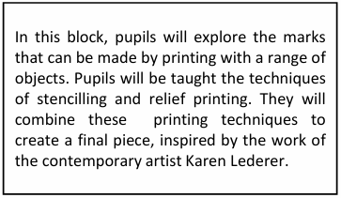  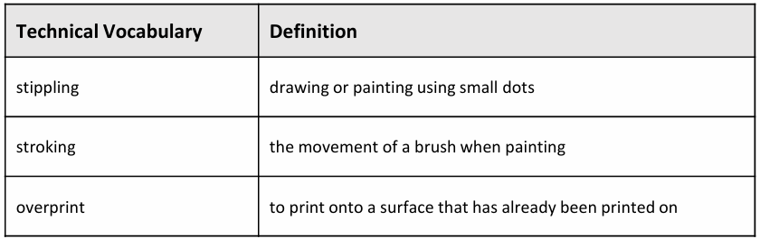  Core knowledge: printmaking, stencil and relief printing |  |  | 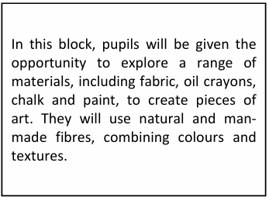  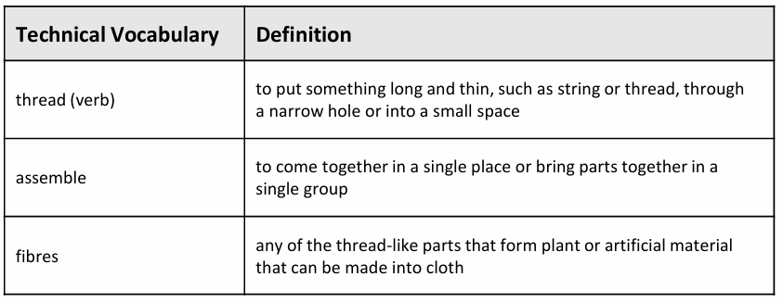  Core knowledge: fabric, yarn and portrait |  |  | HALF  TERM  BREAK | 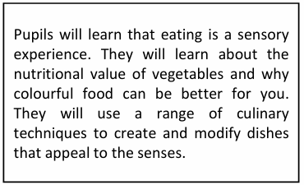  -  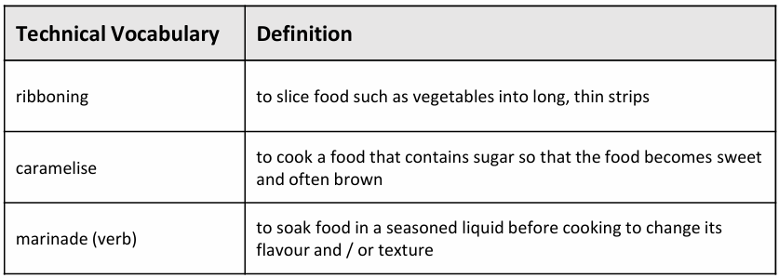 |  | 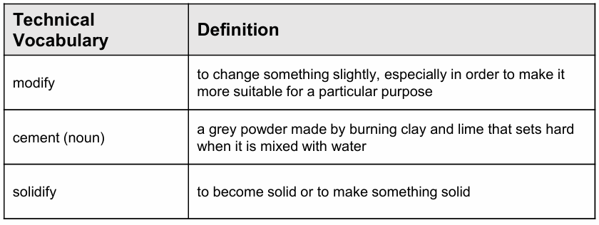  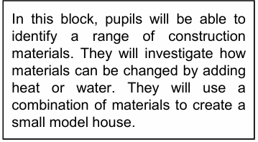

Half-term: 31 May–4 June 2027
SUMMER | Week 1 | Week 2 | Week 3 | Week 4 | Week 5 | Week 6 | Week 7 | HALF  TERM  BREAK | Week 8 | Week 9 | Week 10 | Week 11 | Week 12 | Week 13
SUMMER | 3D Block E |  |  | Creative Response Block F |  |  | Flexible Content | HALF  TERM  BREAK | Textiles Block E |  |  | Food and nutrition Block F
SUMMER | 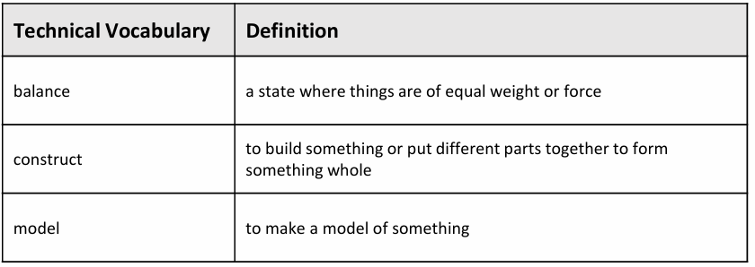  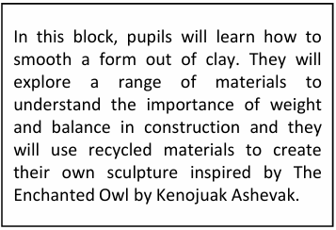  Core knowledge:inuksuk, smooth, pebble |  |  |  |  |  | Flexible Content | HALF  TERM  BREAK | 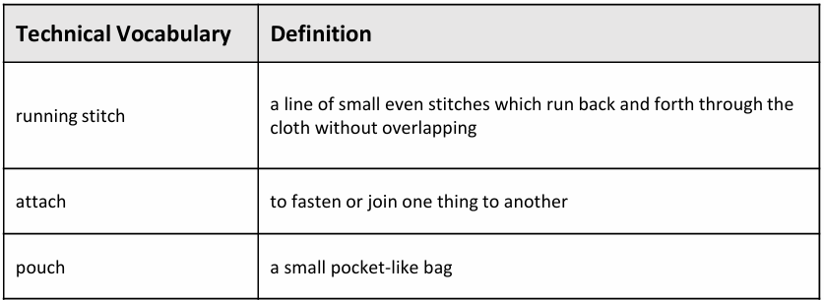  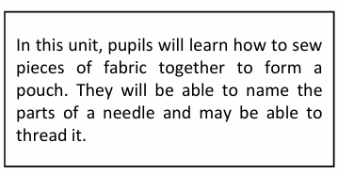 |  |  | 

