Curriculum Overview for Year 6 – Summer 2026
Topic :
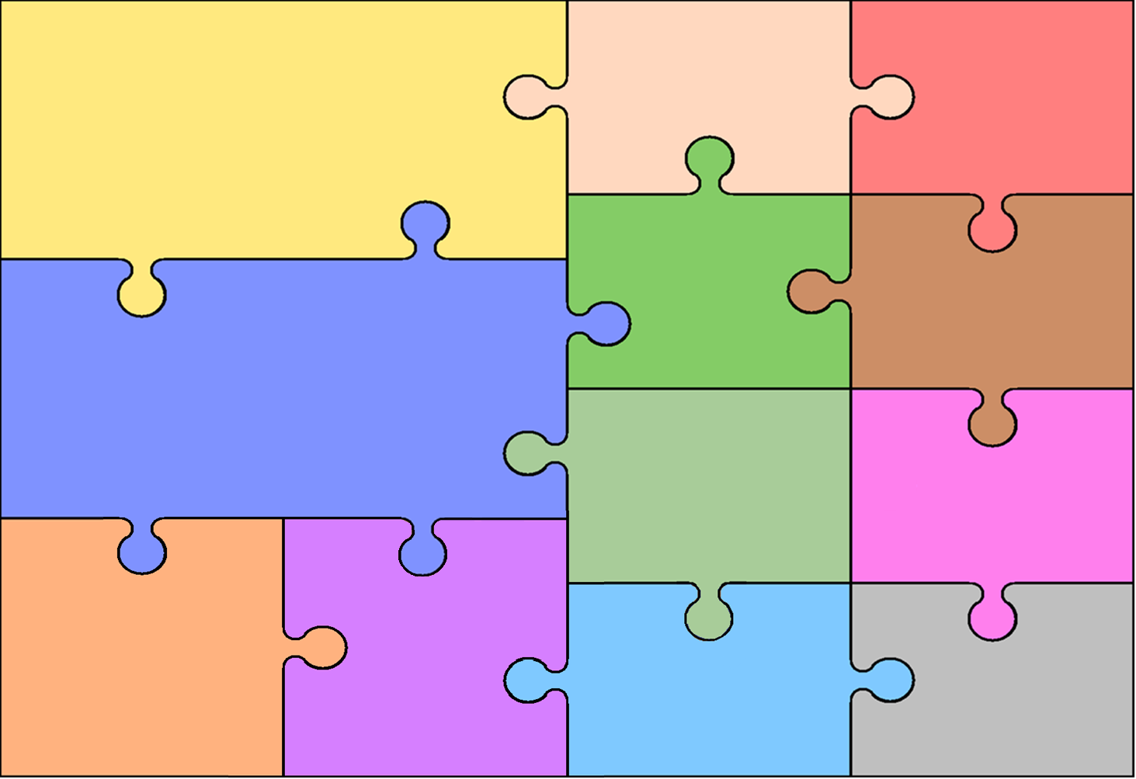
English
Writing
- Key Texts: Shackleton’s Journey and Hansel & Gretel.
- Fiction: Writing an endurance narrative and a dual narrative.
- Non-fiction: Writing a magazine article and persuasive letters.
- Understanding the difference between vocabulary of informal speech and vocabulary
appropriate to formal speech and writing.
- Linking ideas within and across paragraphs using a wider range of cohesive devices.
- Using a range of punctuation to clarify meaning such as commas, semi-colons, hyphens.
Reading
- Exploring vocabulary in context.
- Retrieving and inferring information from a text.
- Summarising a text and making predictions.
- Exploring language and its effect on the reader
Topic- History/Geography
History
- Studying five monarchs to extend their chronological knowledge from 1066
- Exploring why the monarchs are remembered.
- Understanding the legacy the monarch left.
Geography – Geographical Skills and Fieldwork
- Use maps, atlases, globes and digital/computer mapping to locate countries and describe features studied.
- Use the eight points of a compass (including the use of Ordnance Survey maps) to build their knowledge of the United Kingdom and the wider world.

RE/PSHE
RE
- Disposition: Appreciating Beauty. Focus on how Christians celebrate beauty.
- Disposition: Being Curious and Valuing Knowledge. Where is wisdom found? What do followers of Islam do to seek this wisdom?

PSHE
- Being aware of the importance of a positive self-esteem.
- Identifying what they are looking forward to and what worries them about the transition to secondary school.

Mathematics

- Measuring and calculating angles.
- Understanding angles in various shapes.
- Understanding position and direction.
- Exploring and consolidating Mathematics in real-life contexts.

Computing
- Collecting data.
- Formatting spreadsheets.
- Using formulae in spreadsheets.
- Calculating and duplicating in spreadsheets.
MFL
- Ask what the time is in Spanish.
- Tell the time accurately in Spanish.
- Learn how to say what they do at the weekend in Spanish.

Music
- Exploring the important and inspirational role women have in the music industry.
- Rehearse and perform songs for an audience.

Science

- Describe how living things are classified into broad groups according to common observable characteristics and based on similarities and differences, including micro-organisms, plants and animals.
- Give reasons for classifying plants and animals based on specific characteristics.
- Describe the ways in which nutrients and water are transported within animals, including humans.

Art/Design & Technology
Art
Work artistically using: shape, line, form, texture, colour, value and space.
Create a still life using a variety of colours, textures and materials, including paint.
Design & Technology
- Exploring nutrition.
- Exploring other cultures’ foods.
- Explicit teaching of culinary skills and techniques.
- Exploring pulleys and their applications.
- Developing design and problem solving skills.

PE
- Develop a range of athletic techniques.
- Working collaboratively with others.
- Applying rounders’ rules
- Playing small sided rounders’ games with tactics.

