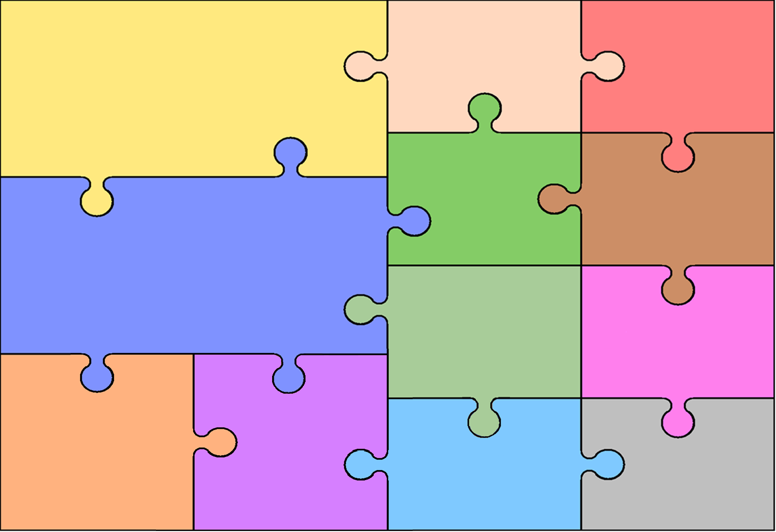
Curriculum Overview for Year 4 – Summer 2026

History
- To explore early civilisations and their achievements.
- To understand who the Ancient Egyptians were and where they lived.
- To learn about the achievements of the Ancient Egyptians including their writing.
- To explore how the River Nile was used.
- To name significant Gods worshipped by Ancient Egyptians.
Carter’s Discoveries
This term the children will explore Ancient Egypt. They will learn about their way of life, their belief in Gods and the importance of the River Nile.

English

Children will be introduced to the high-quality texts ‘The Corinthian Girl’ and ‘Manfish’.

We will be writing a success narrative, an invention narrative and a biography and will focus on the following skills:
- Using a variety of sentence types effectively including the use of fronted adverbials and

conjunctions.
- Using inverted commas and other punctuation accurately in speech.
- Use possessive apostrophes accurately in regular plurals and in words with irregular plurals.
- Focus on verb inflections and nouns/ pronouns to avoid repetition and aid cohesion.
- Using expanded noun phrases and figurative language to add interest to the reader.

Reading:
- Inferring information from fiction and non-fiction texts

and justifying the answers.
- Making comparisons within texts.

Writing:

Art

Music

- To explore contour lines of still life objects.
- To use a viewfinder to select a focal point when drawing.
-To explore painters Giorgio Morandi and Georgia O’Keefe.
- To make sketches following close observation.
- To develop techniques of overpainting and explore tertiary colours.

This term, children will continue to develop their skills playing the tenor horn.
They will play a wide range of songs and focus on timing and playing notes accurately. They will participate in a year group performance.
Mathematics

Measures
- Identify suitable units to measure length, capacity and mass.
- Convert units including cm to m and mm to cm.
- Solve a range of problems involving length, money and time.
Shape and Symmetry
- Compare and order angles.
- Identify right angles, acute angles and obtuse angles.
- Identify lines of symmetry on 2D shapes and complete symmetrical figures.
Position and Direction
- Identify points on a grid as coordinates.
- Plot coordinates on a grid.
- Identify movement on a grid through translation.
Patterns and Sequences
- Identify patterns in number sequences.
- Use Roman Numerals.
- Solving word problems involving patterns.

Geography
RE
Basketball
- To change direction quickly using a crossover dribble.
- To perform a bounce pass.
- To perform a jump shot.
- To perform passing and moving with a teammate.

Athletics
- To accelerate over short distances.
- To run and jump using one-footed take off.
- To run on a curve and exchange a baton with a teammate.
PE
- To know that latitude and longitude tell us what a location will be like.
- To know how to find exact locations around the world.
- - To use maps, atlases, globes and digital/computer mapping to locate countries and describe features studied
- - To use the eight points of a compass and four and six-figure grid references.

Electricity

-To know which appliances use electricity and what sort of power makes them work.
- To name the components in a simple series circuit.
- To investigate what the effect on a circuit the components or batteries are changed.

Sound

- - To identify how sounds are made
- - To find patterns between the pitch of a sound and features of the object that produced it.
- - To recognise that sounds get fainter as the distance from the sound source increases.

Science
Spanish
- To explore key vocabulary for food and drink.
- To perform a short ‘Spanish Café’ role play where children demonstrate how to order food in Spanish.
- To continue to explore nouns, gender, determiners and plurals in Spanish
Relationships
- To understand jealousy is a normal emotion and how to manage those feelings.
- To explore how we get along and what to do when we fall out.
- To know how to show appreciation for others.

Changing Me
- To understand that we are all unique and celebrate this.
- To show confidence when things change around us.
- To discuss the changes that will happen as we transition to Year Five.
Living by The Rules
- To understand the importance of following rules.
- To explore the rules followed by Jewish, Christian and Islamic communities.

Being Temperate, Self-disciplined and Seeking Contentment
- To understand how people around us have helped to shape our behaviour.
- To explore famous Christians, Hindus and Muslims and understand how they have changed the lives of others.

PSHE and
Citizenship

