Curriculum Overview for Year 3 – Summer 2026
Topic :
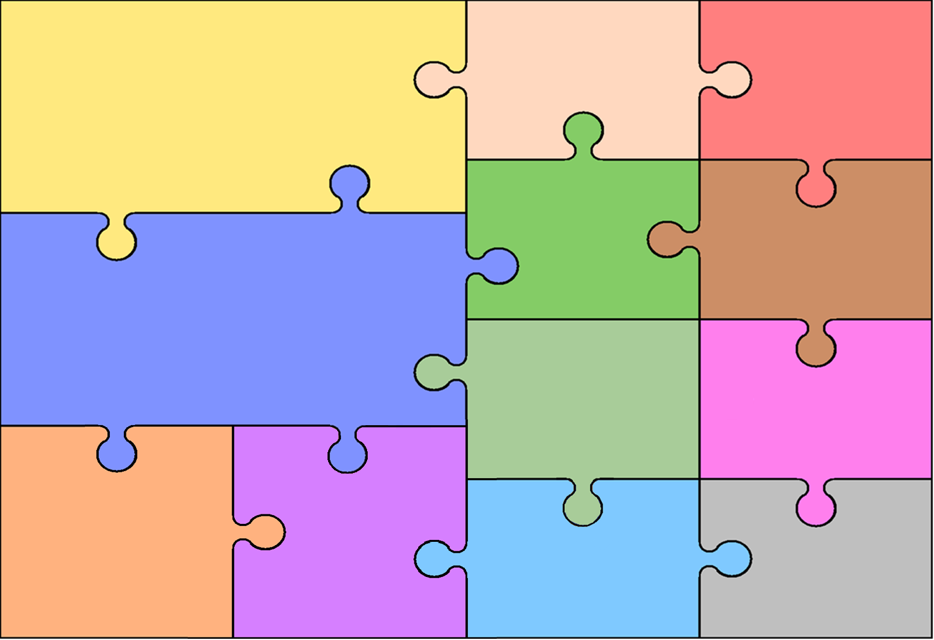
English
Writing
Pip add Egg – A transformation Narrative
The Forgettery - A finding memories Narrative.
The Search for our Cosmic Neighbours - An Exploration Narrative.

Reading
Reading a range of fiction and non- fiction texts.
Explain and justify inferences from texts read.
Understanding new words in different contexts.

Topic
History
Britain from The Stone Age to
The Iron Age
The Roman Empire

Geography
Countries and Regions of the UK.
Human and Physical Geography

RE
Hinduism
Pilgrimage
The River Ganges
Sikhism.
Sharing and community

PSHE
Relationships
Friends and family

Changing me
Express how you feel when changes happen.

Mathematics

Fractions, Mass and Capacity, Money.
Time, Shape, Statistics.
Weekly arithmetic lessons practising skills in all areas of mental maths.

Science
Plants
Light

MFL
Spanish –Mi familia & Mi casa

Computing
Creating documents.
Programing sequences.

Music
Whole class music lessons
Bringing Us Together
Reflect, rewind and replay

PE
Art

Drawing and Painting
Printmaking

Basketball
Athletics

