Curriculum Overview- Reception Summer 2026 – Step Outside/Moving On

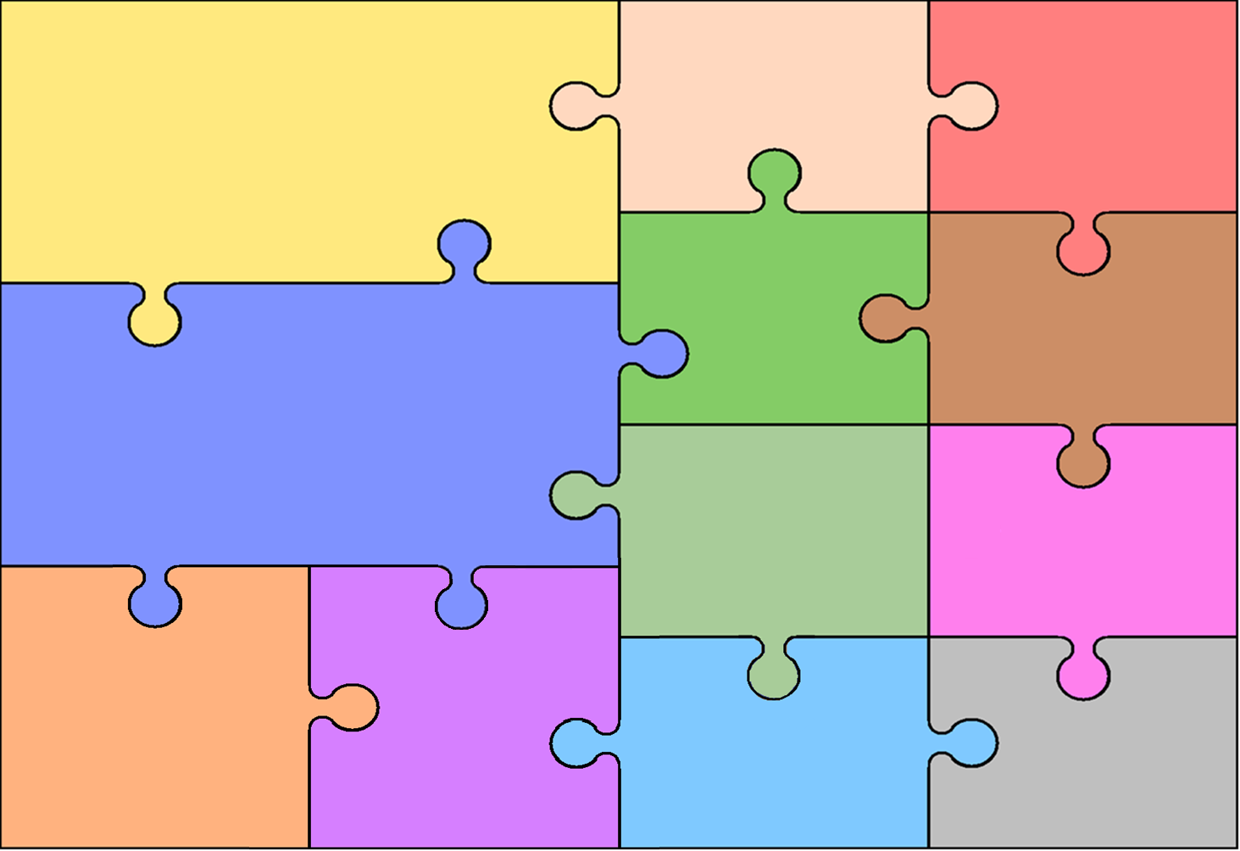
Phonics
Phonics – Phase 3
ai, ee, igh, oa, oo, oo, ar, or, ur, ow, oi, ear, air, er

Literacy

To spell some words correctly and others how they phonetically sound.
To write simple sentences that can be read by themselves and others.
To write using key features of narrative (e.g. to write a story)
To write some common irregular words (the, is, no, go, was, to etc.)
To use phonic knowledge to decode, segment and blend words – saying a sound for each letter in the alphabet and at least 10 digraphs.
To read simple sentences and talk about what they have read.
To explore and understand new vocabulary that is influenced by topics and stories and use this in discussions.
To anticipate and talk about key events in stories and predict what may happen.

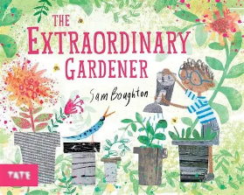

.

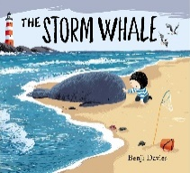

Communication and Language

To listen to stories, accurately anticipating key events and respond to what they hear with relevant comments, questions or actions.
To give their attention to what others say and respond appropriately, even while engaged in another activity.
To join in with discussions with adults and children.
To follow instructions with several actions.
To answer ‘how’ and ‘why’ questions to clarify understanding.
To express themselves effectively, showing awareness of listeners’ needs.
To use past, present and future forms accurately when talking about events that have happened or are to happen in the future.

Mathematics
To talk about past and present events in their own lives.
To talk about similarities and differences between themselves and others, and among families, communities and traditions and also in relation to places, objects, materials and living things.
To talk about the features of their own immediate
environment and how environments might vary
from one another.
To make observations of animals and plants and explain
why some things occur, and talk about changes.
Explore the natural world through outdoor learning.

Expressive Art and
Design
To safely use and explore a variety of materials, tools and techniques, experimenting with colour, design, texture, form and function.
To use what they have learnt about media and materials in original ways, thinking about uses and purposes.
They represent their own ideas, thoughts and feelings through expressive arts,
Sing a range of well-known nursery rhymes and songs.
To develop their own settings, props and narratives to enhance their play.

Understanding the World

Physical Development

To form letters neatly, correctly and hold a pencil effectively.
To use a range of tools effectively e.g. scissors, playdough tools, paint brushes and cutlery when eating,
To move confidently in a range of ways, showing good control in movement, coordination and balance.
To negotiate space safely and successfully e.g. when running or playing a game.
Balanceability – Learning how to ride and steer a balance bike.

To count reliably with numbers from one to 15
To place numbers from 1 – 15 in order and say which number is one more or one less than a given number.
To add and subtract two single-digit numbers and count on or back to find the answer.
To use mathematical thinking to solve problems, including doubling, halving and sharing.
To use language related to size, weight, capacity, money, time, position and distance to compare quantities and solve problems.
To name and talk about the properties of 3D shapes.

Personal, Social and Emotional Development

Focus during longer whole-class lessons.
To follow two-step instructions.
Identify and moderate their own feelings socially and emotionally, showing resilience and perseverance in the face of challenge.
Know and talk about different factors that health and wellbeing – e.g. healthy eating/tooth brushing/being a safe pedestrian.
Begin to think about the perspective of others, take turns and work in a group.

=

